Imagine that you’re a new grad student and you have to do a first year project. Your advisor really likes a series of datasets comprising the National Longitudinal Study of Adolescent Health (Add Health) that was conducted from 1994-2008. In keeping with the great grad student tradition across the land, you now find yourself very “interested” in this study as well.

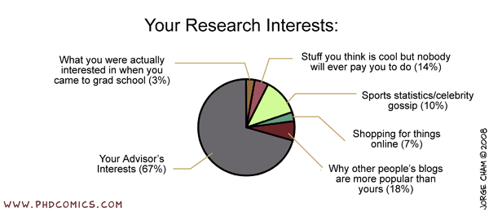

You’re advisor gives you codebooks, data files, syntax to read the data files into R (this crazy program to manage and analyze data) and gives you the vague assignment of developing three distinct, but thematically related, hypotheses. Use the LYS data sets to test your hypotheses, then write everything up into a short research paper to serve as a proposal for your project.

Down to the nitty-gritty:

1. Your paper can be as long as you like, but I expect about 7 pages as a minimum. About 1-2 for a short intro explaining the hypotheses you came up with, 1-2 describing the variables you’re interested in testing, 1-3 for results, and 1-3 for discussion.
2. Intro: You do not need to cite sources for this paper. I don’t care if you have legitimate background theory or if you just have several reasonable rationalizations. All I’m looking for is some sort of justification for the hypotheses you will propose.
3. Variables used: You will need to describe the variables you select to use, or that you create from selected variables (for example, if you make a sum score of some items). This is particularly important because the LSY study contains A TON of variables.
4. Results: I am looking for interesting analyses. I do not want you to conduct a series of factorial ANOVA models using a small set of variables. Think of this as an opportunity to express your creativity with a huge data set that is bound to have some variable that will enable you to entertain your personal interests and serve as good research practice in analyses and reporting.
5. Discussion: I want you to really interpret your results in detail, and to describe to some degree what this may mean broadly with respect to the hypotheses you developed.
6. Use APA format for the entire report. As I indicated, citations are optional, therefore references are also optional.
7. You should include tables and figures to help explain your data and results.
8. You should include an appendix containing all of your R code used to manipulate and analyze the data.

\*\*\*\* Include all R code in Appendices so I can review it.

\*\*\*\* Hard copies due to me by the end of lecture on Thursday Dec. 3, 2015.

\*\*\*\* Grading will be based on completeness of answers, quality of reports, and both efficacy and efficiency of your code.

\*\*\*\* These projects should represent your own work (not online resources or other students).